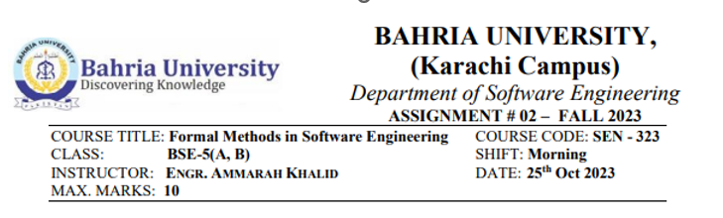

**Question#1**

Refer to the Document control system given in the book “The way of Z” by Jonathan Jacky, define the normal Checkin operation, and a total TCheckln operation that accounts for the exceptional cases in Document Control System.

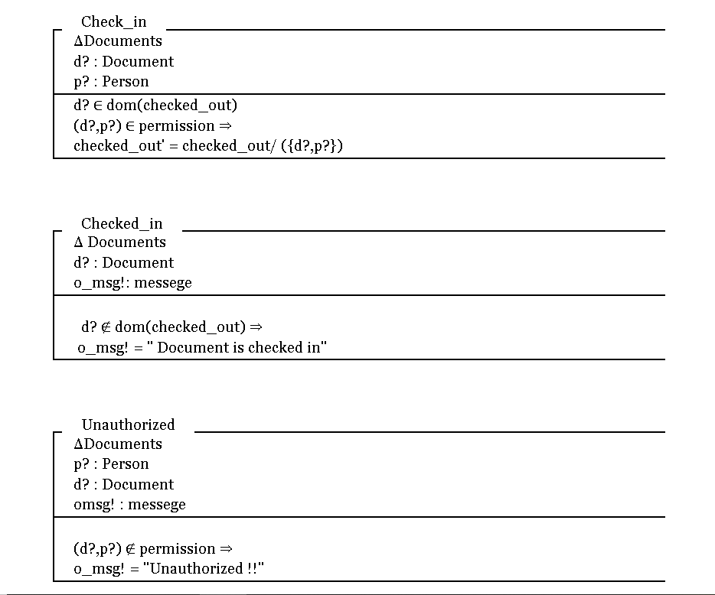



**Question#2**

**PART -A**

Arrival of plane

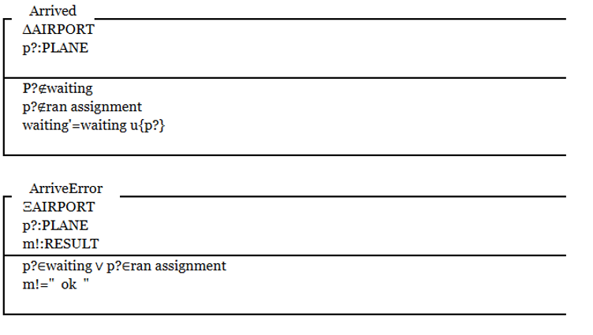

**PART -B**

Assignment of plane

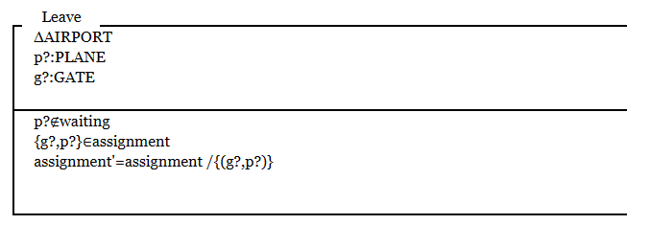

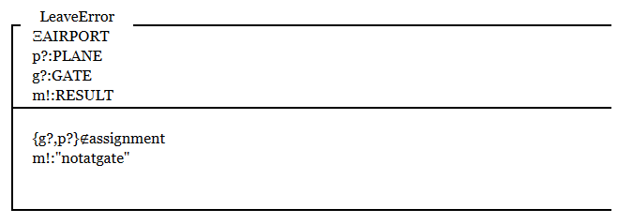

**PART -C**

Plane leaving the gate





XXXXXXXXXXXXXXXXXXXXXXXXXXXXXXXXXXXXXXXXXXXXXXXXXXXXXXXXXXXXXXXXXXXX